Holy Week 2021 Monday. Clearing the temple & Cursing the Fig Tree.

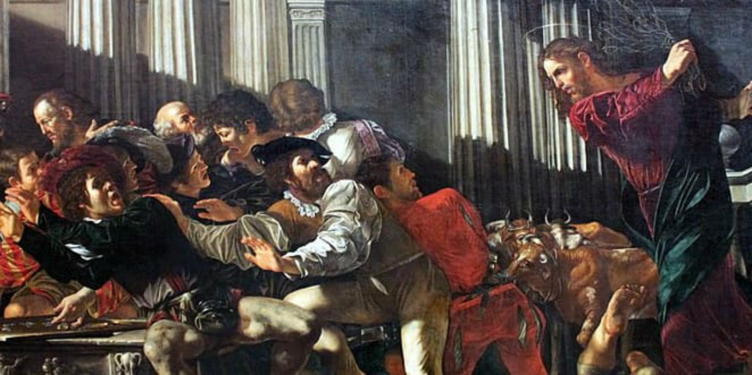

No doubt as Jesus left the temple area on Palm Sunday he had a lot on his mind.

Perhaps he thought of the dedication of the first temple ever built in Israel, Solomon's temple. After all, Jesus did have a way of bringing an eternal perspective on things, and he may have thought about how the life of the temple had changed since Solomon’s time and the way things should be. On the day the first temple was dedicated, God's glory dominated the scene...
Solomon, on the day of dedication, prayed:
"Now arise, O Lord God, and come to your resting place...May your priests,
O Lord God, be clothed with salvation, may your saints rejoice in your goodness..."
When Solomon finished praying, fire came down from heaven and the glory of the Lord filled the temple. "The priests could not enter the temple of the Lord because the glory of the Lord filled it. When all the Israelites saw the fire coming down and the glory of the Lord above the temple, they knelt on the pavement with their faces to the ground, and they worshiped and gave thanks to the Lord, saying 'He is good; his love endures forever.'"
(see II Chronicles 6:41-7:3)
This was a picture the children of Israel had when they thought of the temple, a place where God dwelt. A holy place where people bowed their hearts to him, worshipped, prayed, and adored God. The picture Jesus saw was quite different. The temple had become a marketplace where, instead of people bowing their heads and praying with their hearts, they were more interested in turning a profit. A pretty far cry from God's original intention.

Reflection: "When God first drew me into a relationship with him, he had something good, pure and life-changing in mind. Is my relationship with him still characterized by that simple purity and life-changing devotion?
Prayer: "Lord, forgive me for cheapening your presence in my life. Fill the temple of my heart with your over-powering glory once again."
The next morning on his way to the temple Jesus saw a fig tree, but it didn't have any fruit for him to eat, even though it was loaded with leaves. He pronounced a curse on it and died that day. What good was a fig tree if it didn't bear fruit? Like the temple it was not just to be admired or used, it was meant to bear fruit.
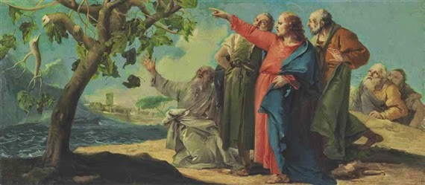

So what good is a temple or church if people don't meet God there? It's supposed to be a place where your soul gets fed. That's its purpose after all. Not just to look beautiful and draw admiration because of its architecture or structure.
On the outside, the temple was a busy place but on the inside it was dead. The temple was supposed to be a house of prayer. Instead, it had become a place of preoccupation and spiritual distraction robbing people's hearts from their God. Jesus cursed the temple too, by clearing out the money changers and teaching the merchandisers a lesson because that wasn't what the temple was for.
Reflection:
I sense my life is cluttered with things that distract me from connecting with God on a more intimate level.
What things do I need to clear out of my life?
Am I really willing to de-clutter my life?
Am I willing to simply pray and wait upon God?
Or am I content with avoiding God by doing the business of 'Christian activity'?
I will take time to listen to God and meet with God this week."
Prayer: "Lord, clear out my heart. Do what you will, even to the point of 'over-turning' my tables. Remodel my inner world."
On the second day of Jesus' final week, he made it quite clear his work of putting things right. That takes courage and there was an urgency in his manner revealing he was definitely not weak. He was resolute in revealing just what God has in mind for his people, knowing full well that in just a matter of days he would arrested and executed. So, at the end of that second day he left the city for a rest in Bethany, possibly staying with his friends again. After a display of strength, the Saviour of the World (the Maker of the fig tree and the God of the temple) needed a rest.
Digging Deeper
Try reading Mark's gospel account of Day 2 and take time to imagine yourself in the scene:
Mark 11:12-19

